Tech Problem
The Halfway Do it Mine is a 3-entry development. Air enters the mine through the # 3 entry and exits the mine through the #1 and #2 entries. You are standing in the #2 entry. You will need to determine the airflow in the #2 entry using a vane anemometer and using a smoke tube. Take a reading from the test port in the permanent stopping with man door between the #1 and #2 entries using the magnehelic gauge.

Field Set-Up

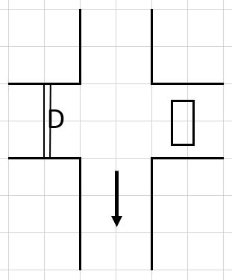
Field Set-Up Notes
Use 10 feet widths on the field. The pipe used for height can be anything measurable. I am providing the heights and widths for each exercise (anemometer and smoke tube). They will be different.
Anemometer
Width 19.5 feet
Height 4.5 feet
Anemometer Reading – “See Anemometer Picture”
Anemometer Reading is 535 ft/min
Correction Factor is -6
Corrected Anemometer Reading is 529 ft/min
Area is 87.75 ft²
Airflow is 529 ft X 87.75 ft² = 46,419.75 CFM

Smoke Tube
Width 19 feet
Height 5 feet
Smoke Tube – measure off 10 feet

Quadrant 1 time is 12 seconds
Quadrant 2 time is 13 seconds
Quadrant 3 time is 15 seconds
Quadrant 4 time is 10 seconds

Avg Time = 12.5 sec
Velocity = 10 ft/12.5 sec = 0.8 ft/sec = 48 ft/min
Area = 95 ft²
Air Flow = 95 ft² X 48 ft/min = 4560 CFM

Magnehelic
Magnehelic Reading – “See Magnehelic Picture”
Magnehelic Reading is 0.22 in H₂O
Reflected as “Positive” [should use high pressure hose]

